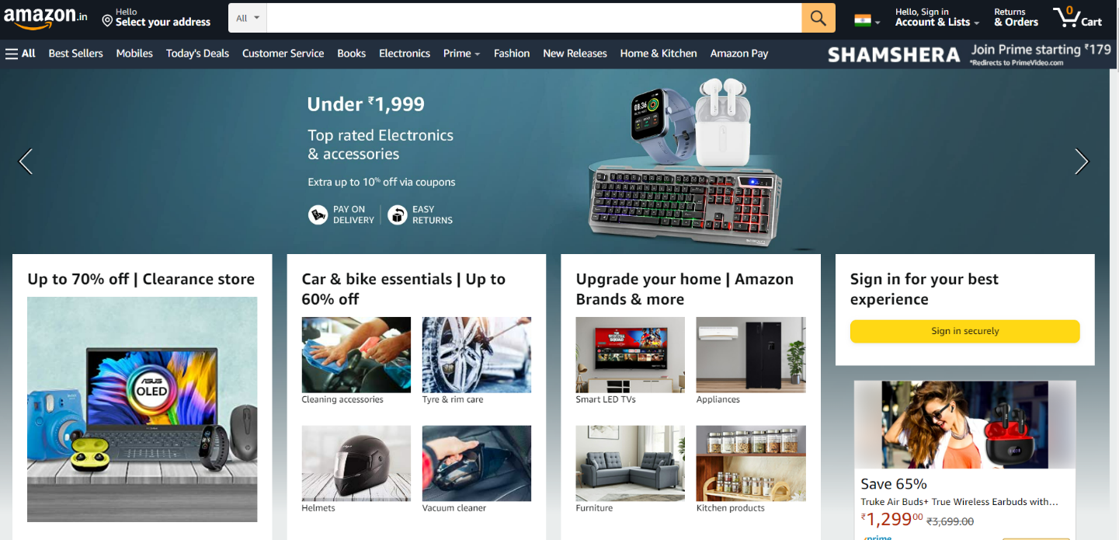

Project Name: Amazon Clone

Akhil Prakash

Overview

**Amazon is a largest online market in India. Amazon product lines include (books, DVDs, music CDs, videotapes, and software), apparel, baby products, consumer electronics, beauty products, gourmet food, groceries, health and potty for those who wanted personal-care items, industrial and scientific supplies, kitchen items, jewelry etc.**

Goals

1. Registration page

2. Profile page

3. Payment page

4. Product related pages

**History**

Amazon.com, Inc. is an American multinational technology company which focuses on e-commerce, cloud computing, digital streaming, and artificial intelligence. It has been referred to as "one of the most influential economic and cultural forces in the world", and is one of the world's most valuable brands.

The company took its first steps into the Indian market in February 2012 when it launched Junglee.com, a site which allowed customers to compare prices online but not purchase items directly. It will initially only sell books, films and TV shows but plans to offer mobile phones and cameras within weeks.

**Technologies used in Amazon**

Front-End:

1. Html
2. CSS
3. Bootstrap

Back-End:

1. Node JS + Express
2. Mongo DB

Code Compilers:

1. Visual Studio Code

Version Controller Tool:

1. Git

https://github.com/Akhilprakashdeveloper/Projectdocuments